**THERAPISIA – A MENTAL HEALTH CHATBOT**

## **A MINI-PROJECT REPORT**

*Submitted by*

**ROSHINI RAJA 2116210701216**

**SELVAN NANDHINI S 2116210701237**

**SHAMINI P N 2116210701239**

***In partial fulfilment of the award of the degree***

***of***

# **BACHELOR OF ENGINEERING**

**IN**

**COMPUTER SCIENCE AND ENGINEERING**

**RAJALAKSHMI ENGINEERING COLLEGE**

**AUTONOMOUS, CHENNAI**

**MAY 2024**

**BONAFIDE CERTIFICATE**

**Certified that this project report “THERAPISIA-Mental Health Chatbot” is the bonafide work of “ROSHINI R (210701216), SELVA NANDHINI S (210701237), SHAMINI P N (210701239)” who carried out the project work under my supervision.**

|  |  |
| --- | --- |
| **Dr. P. Kumar**  **HEAD OF THE DEPARTMENT**  **Professor and Head**  Department of  Computer Science and Engineering  Rajalakshmi Engineering College  Rajalakshmi Nagar  Thandalam  Chennai - 602105 | **Mr.Vijay K**  **B.Tech., M.E.,**  **Assistant Professor (SG)**  **SUPERVISOR**  **Associate Professor**  Department of  Computer Science and Engineering  Rajalakshmi Engineering College  Rajalakshmi Nagar  Thandalam  Chennai - 602105 |

**Submitted to Project Viva-Voce Examination held on _20-05-2024________.**

**Internal Examiner External Examiner**

**TABLE OF CONTENTS**

**CHAPTER NO. TITLE PAGE**

**ABSTRACT**  **1**

1. **INTRODUCTION** **2**
   1. INTRODUCTION 2
   2. SCOPE OF THE WORK 2
   3. PROBLEM STATEMENT 3
   4. AIM AND OBJECTIVES OF THE PROJECT 3
2. **LITERATURE SURVEY 4**
3. **EXISTING SYSTEM 6**
4. **PROPOSED SYSTEM 7**
5. **SYSTEM DESIGN** **8**
   1. ARCHITECTURE DIAGRAM 8
   2. CHATBOT ARCHITECTURE 9
6. **MODULE DESCRIPTION 10**
   1. USER INTERFACE10
   2. CHATBOT RESPONSE 10
7. **SAMPLE CODING** **11**
8. **RESULT** **16**
9. **CONCLUSION AND FUTURE ENHANCEMENT** **17**

**REFERENCES 18**

**ABSTRACT**

Mental health is a major concern in today's environment. With the world becoming more and more competitive every day, the number of people suffering from stress and other mental health issues is exponentially increasing.There are various reasons why People get stressed.Like students get stressed for high expectations in academic performance, peer pressure, financial problems etc.The mental health of an individual is as important as physical health is.Due to advancements in Artificial Intelligence, chatbots have made our lives easier as we can get to know about many things at our fingertips.So,there are many chatbots available that do the work related to particular things like Chatgpt for content creation and blackbox ai for solving complex coding problems etc.

Thinking of it, we have created an AI Mental Health Therapist Chatbot(MHTC) named Therapisia to address the problems related to mental health issues and to provide a medical recommendation according to the problem the user might be facing. The goals include offering non-judgmental support, providing personalised advice and coping strategies, and complementing traditional therapy by offering continuous support and self-help resources. It will be able to provide medical support which is cost effective and also recommend the treatment and tips required to the user. This advancement in the field of AI which can gain popularity among people especially students who cannot afford therapist consultation and can chat and get assistance anytime they want.

Keywords:

MHTC-Mental Health Therapist Chatbot NLP-Natural Language Processing

NLU-Natural Language Understanding LLM-Large Language Model

**INTRODUCTION**

**1.1 INTRODUCTION:**

Just like physical health, mental health also plays a vital role in determining the lifestyle of an individual. A healthy mind is crucial towards leading a healthy lifestyle. Many individuals might experience anxiety, stress or depression which makes them feel powerless, unworthy of themself with unhappiness and loneliness for no well-known reason. Our AI Mental health Chatbot Therapisia is developed using Gemini Pro. Our chat interacts with user and offers advice and suggestions for their queries.It is available 24/7 so the user can use it anytime.This advancement in the field of AI which can gain popularity among people especially students who cannot afford therapist consultation and can chat and get assistance anytime they want.

**1.2 SCOPE**:

Our mental health chatbot has the potential to greatly assist individuals by offering immediate support for conditions such as anxiety and depression. It can provide guidance, share valuable resources, and remain accessible around the clock. This accessibility eliminates concerns about lengthy wait times or societal stigmas, ensuring that anyone can seek assistance at any time. Additionally, the chatbot can be programmed to prioritise privacy and deliver empathetic, accurate responses, rendering it an invaluable resource for countless individuals.mental health services. Also, the fact that they're available 24/7 means you can get help whenever you need it. Therapisia could even offer personalised therapy and intervention strategies, making them even more effective at addressing mental health concerns.

**1.3 PROBLEM STATEMENT**:

A lot of people struggle with mental health issues like anxiety and depression, but it can be tough to get help. The usual mental health services have long wait times and might not be an option for everyone, especially those in remote areas. There's also a stigma around seeking mental health support, which stops many from reaching out. Our Mental health chatbot provides an intuitive user-friendly interface that makes it easier to use.

**1.4 AIM AND OBJECTIVES:**

Therapisia is a AI Mental Health Therapist Chatbot named Therapisia to address the problems related to mental health issues and to provide a medical recommendation according to the problem the user might be facing. The goals include offering non-judgmental support, providing personalised advice and coping strategies, and complementing traditional therapy by offering continuous support and self-help resources. It will be able to provide medical support which is cost effective and also recommend the treatment and tips required to the user. It also offers anonymity so users can use it without their identity.

**LITERATURE SURVEY**

1.The systematic review and meta-analysis conducted by Abd-Alrazaq, Alaa Ali, et al. titled "Effectiveness and safety of using chatbots to improve mental health" was published in the Journal of Medical Internet Research in 2020.

“Abd-Alrazaq, Alaa Ali, et al. "Effectiveness and safety of using chatbots to improve mental health: systematic review and meta-analysis." Journal of medical Internet research 22.7 (2020): e16021.”

2.To design and implementation of a chatbot intended to facilitate deep self-disclosure to a real mental health professional.

“Lee, Yi-Chieh, Naomi Yamashita, and Yun Huang. "Designing a chatbot as a mediator for promoting deep self-disclosure to a real mental health professional." Proceedings of the ACM on Human-Computer Interaction 4, no. CSCW1 (2020): 1-27.”

3.McIntosh et al. (2023) present a comprehensive outline of the generative AI discipline, which is formed the basis of Google Gemini thinking.

“McIntosh, T.R., Susnjak, T., Liu, T., Watters, P. and Halgamuge, M.N., 2023. From google gemini to openai q*(q-star): A survey of reshaping the generative artificial intelligence (ai) research landscape. arXiv preprint arXiv:2312.10868.”

4.This case is presented under the heading Google vs. ChatGPT: the evaluation of retinal detachment case comparison through AI chatbots performs the task of the three presented chatbots namely, ChatGPT, Google Twins, and the third entity in whatever it is," thus the performance is comparatively witnessed to be in the case of the three chatbots, ChatGPT, Google Twins and the third asked AI chatbot.

“Carlà MM, Gambini G, Baldascino A, Giannuzzi F, Boselli F, Crincoli E, D’Onofrio NC, Rizzo S. Exploring AI-chatbots’ capability to suggest surgical planning in ophthalmology: ChatGPT versus Google Gemini analysis of retinal detachment cases. British Journal of Ophthalmology. 2024 Mar 6.”

5.This publication has a focus on unfolding the techniques and aspects regarding distinguishing between the content created by language models and the real one.

“Tang R, Chuang YN, Hu X. The Science of Detecting LLM-Generated Text. Communications of the ACM. 2024 Mar 25;67(4):50-9”.

**EXISTING SYSTEM**

Several approaches to building mental health chatbots, which use the most recent achievements of modern AI and NLP, have been already suggested, and their functioning is based on the latest AI achievements allowing to provide more effective mental health support to the larger group of people. Instances of this fashion are Woebot, which works on CBT concepts for mood inquiry and interventions and Wysa which is a stress Manager application with added CBT and mindfulness approaches. What I have come up with is the interaction with the Replika app where it starts like having a relationship and at some point the conversation is taking a change that also lets the user communicate and talk with certified psychotherapists. However, Youper would roll out an AI having elements of emotional intelligence not only for feeling of the mood but it also offers ways of coping with the same, Joy requires the combination of the chatbot and human providers to achieve a similar effect. The other ones, such as Mindbloom, Shine, Therachat, and Tess, are devoted to the whole well-being, community support, therapist-patient communication and also respectively. For instance, the application of all the engineered systems contributes to the collective response to a demand for obtaining mental assistance irrespective of what the request is for or a person’s preferences in the digital environment.

**PROPOSED SYSTEM**

‘THERAPISIA’, our proposed platform, where we used gemini pro a pre-trained model used to develop a mental health chat bot. Developing mental health chatbot is necessary for various reasons and the choice of pre-trained model like Gemini Pro is also included. Since, Gemini pro has the capability of (NLP)Natural Language Processing,advanced features and versatility.It has unique strength and large potential impact for improving the accessibility and efficiency for the user.The Natural Language Processing architecture enables the chatbot to understand and analyse the user input with more accuracy.

Moreover,Gemini Pro excels in understanding and determine the aspect of developing a mental health chatbot. Mental health conversation often involve complicated issues that include various emotions and behavioural patterns.The chatbot is able to clarify and inspect the user queries and generate the responses based on that.Emotion recognitions another strength of Gemini Pro which is well-suited for mental healthcare.By analysing users language and tone the model can detect their emotion state.This capability enables the Chatbot to respond based on the user emotion that has been analysed.

Furthermore,Gemini Pro facilitates personalization, it can also adapt its response and recommendations based on the user preferences and progress.It enhances the user engagement,satisfaction and motivation. It is more scalable and flexible for the user to interact with the chatbot. The Gemini Pro emerges as a major choice for the development of Mental Health Chatbot due to its capability of NLP and other advanced features to generate response based on user response.

**SYSTEM ARCHITECTURE**

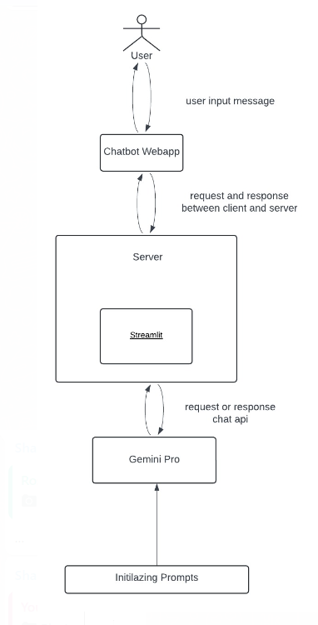

Fig1. Architecture Diagram of Mental Health Chatbot

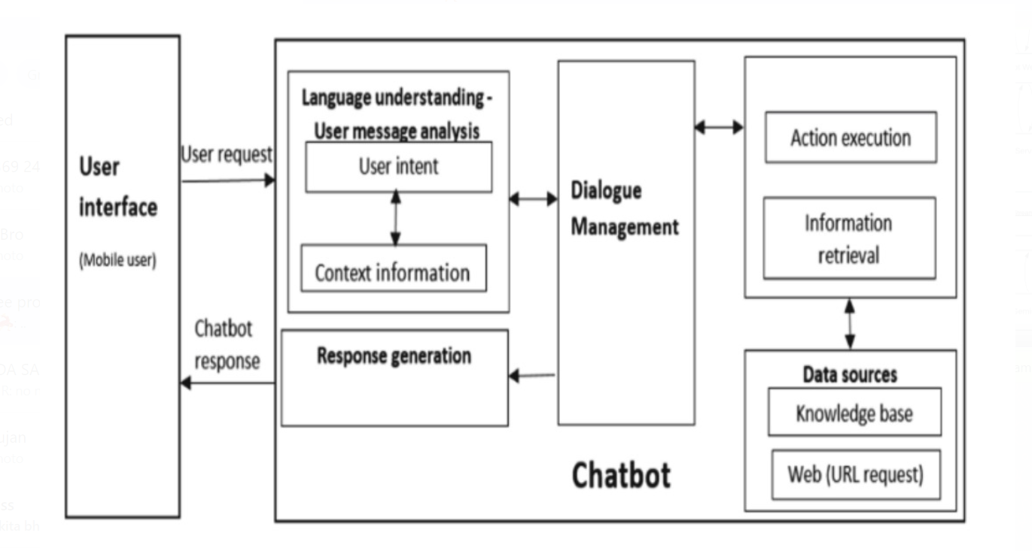

Fig2. Chatbot Architecture

**MODULES**

**1.USER INTERFACE:**

**Fig 1. User interaction**

The user interface of a mental health chat bot app will be intuitive and calming. Featuring a minimalist design Interactive elements like quick response buttons and progress trackers enhance engagement and ease of use.

**2.Response Generation:**

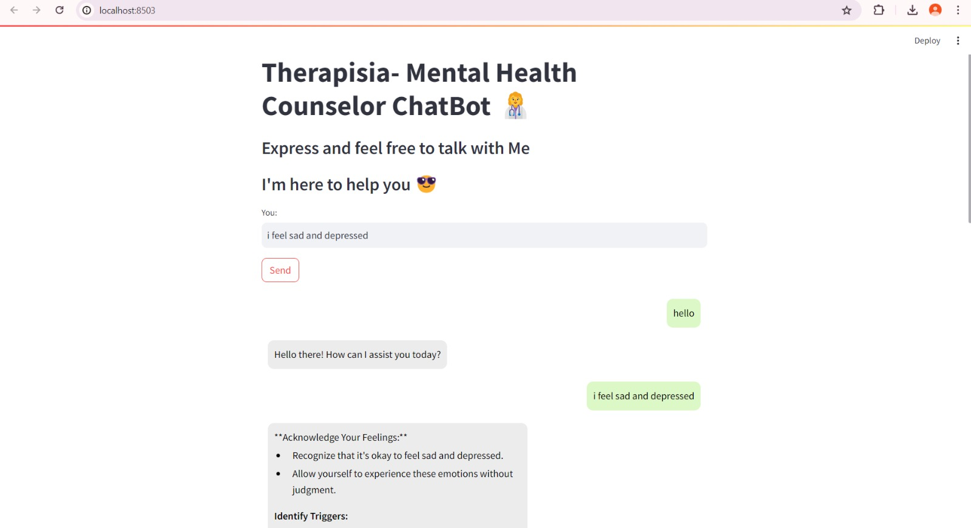

**Fig 2.Chatbot Response**

The chatbot response interface gives back the response when the user prompts a query

**SAMPLE CODING**

import os

import streamlit as st

import google.generativeai as genai

# Initialize the Gemini-Pro model

os.environ['GOOGLE_GEMINI_KEY']="AIzaSyBoVQYDOeYH8L4GZRL6b82nJAZJi-A"

genai.configure(api_key=os.getenv('GOOGLE_GEMINI_KEY'))

model = genai.GenerativeModel('gemini-pro')

# Define the function to send the user's message to the model and get the response

def get_model_response(user_input):

prompt = "act only as a professional mental health therapist answer my query with your best possible response in short not more than one paragraph, can ask questions like a therapist..."

response = model.generate_content(user_input)

return response.text

# Define a function to convert the role of the message to a Streamlit chat message role

def role_to_streamlit(role):

return "Therapist" if role == "Bot" else "User"

# Display the chat interface

def main():

st.set_page_config(page_title="Therapisia",

page_icon='👩‍⚕️',

layout='centered',

initial_sidebar_state='collapsed')

st.title(" Therapisia- Mental Health Counselor ChatBot 👩‍⚕️")

st.subheader("Express and feel free to talk with Me")

st.subheader("I'm here to help you :sunglasses:")

# Initialize chat history

if 'chat_history' not in st.session_state:

st.session_state.chat_history = []

# Display user input box and send button

user_input = st.text_input("You: ", key="user_input")

if st.button("Send") and user_input:

st.session_state.chat_history.append(("User", user_input))

bot_response = get_model_response(user_input)

st.session_state.chat_history.append(("Bot", bot_response))

# Display chat history

if st.session_state.chat_history:

for role, message in st.session_state.chat_history:

message_html = f"""

<div class="{'user-message' if role == 'User' else 'bot-message'}">

<div class="message">{message}</div>

</div>

"""

st.markdown(message_html, unsafe_allow_html=True)

# Adjust layout

st.markdown("""

<style>

.stTextInput>div>div {

width: 70%;

}

.user-message {

display: flex;

justify-content: flex-end;

margin: 10px;

}

.bot-message {

display: flex;

justify-content: flex-start;

margin: 10px;

}

.message {

max-width: 60%;

padding: 10px;

border-radius: 10px;

background-color: #dcf8c6; /* User message background */

color: #000;

font-size: 16px;

}

.bot-message .message {

background-color: #ececec; /* Bot message background */

}

</style>

""", unsafe_allow_html=True)

if __name__ == "__main__":

main()

**IMPLEMENTATION AND RESULTS**

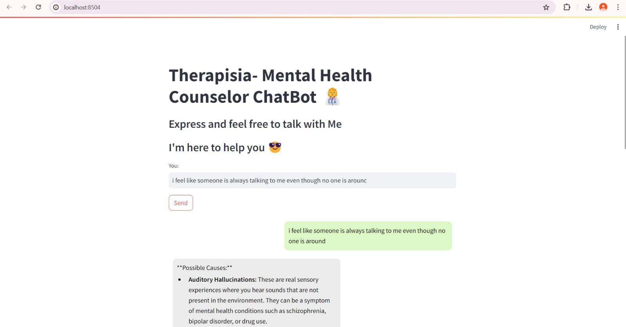

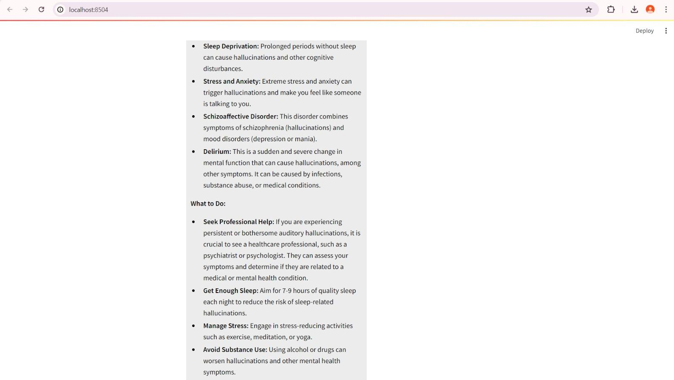

The implementation of the mental health chatbot involves natural language processing to understand user inputs and improved mental health outcomes, by giving tips and positive feedback on accessibility and reliability. In our mental health chat app offers real-time support, confidential space for individuals to share their thoughts and feelings

**CONCLUSION AND FUTURE WORKS**

A mental health chatbot Therapisia powered by Gemini Pro has some great benefits. It's there 24/7, so you can get help right away without having to make appointments, which is super helpful in tough times. The chatbot can understand and respond to your emotions in a really human-like, caring way which makes you feel heard and supported.

It can handle all sorts of inputs making communication more effective.

Plus, it keeps everything anonymous, so you can open up without worrying about being judged or mistaken. And it's affordable, making mental health support available to more people. Overall, it's always there for you, it is understanding and flexible. It is also cost -effective which makes everybody use it. In future works,voice recoginsation include enhancing emotional detection,better understanding

**REFERENCES**

[1] Mahindru A, Patil P, Agrawal V. Role of Physical Activity on Mental Health and Well-Being: A Review. Cureus. 2023 Jan 7;15(1):e33475. doi: 10.7759/cureus.33475. PMID: 36756008; PMCID: PMC9902068.

[2] Therapy Chatbot: A Relief From Mental Stress And Problems Pranav Kapoor, PrathamAgrawal,ZeeshanAhmad [10.14299/ijser.2021.05.08](http://dx.doi.org/10.14299/ijser.2021.05.08)

[3] Gratzer D, Goldbloom D. Open for business: chatbots, e-therapies, and the future of psychiatry. Can J Psychiatr. 2019;64(7):453–455.

[4] Torous J, Wiśniewski H, Liu G, Keshavan M. Mental health mobile phone app usage, concerns, and benefits among psychiatric outpatients: comparative survey study. JMIR Mental Health. 2018;5(4):e11715.[Nesi et al. 2022](https://paperpile.com/c/wVG5Ql/Vuw5)

# [5] Eileen Bendig; Benjamin Erb; Lea Schulze-Thuesing; Harald Baumeister The Next Generation: Chatbots in Clinical Psychology and Psychotherapy to Foster Mental Health –A Scoping review [doi.org/ 10.1159/000501812](https://doi.org/10.1159/000501812)

# [6] Hamid Reza Saeidnia [Tarbiat Modares University](https://www.researchgate.net/institution/Tarbiat_Modares_University?_tp=eyJjb250ZXh0Ijp7ImZpcnN0UGFnZSI6InB1YmxpY2F0aW9uIiwicGFnZSI6InB1YmxpY2F0aW9uIn19)Welcome to the Gemini era: Google DeepMind and the Information Industry December 2023 [10.1108/LHTN-12-2023-0214](http://dx.doi.org/10.1108/LHTN-12-2023-0214)

[7] A. M. Nayar, Z. Attar, S. Kachwala, T. Biswas and S. K. Wagh, "Dost-Mental Health Assistant Chatbot," 2022 5th International Conference on Advances in Science and Technology (ICAST), Mumbai, India, 2022, pp. 252-257, doi: 10.1109/ICAST55766.2022.10039576.

[8] A. Goel, Satyam and S. Sharma, "Artificial Intelligence based Healthcare Chat Bot System," 2023 8th International Conference on Communication and Electronics Systems (ICCES), Coimbatore, India, 2023, pp. 1362-1366, doi: 10.1109/ICCES57224.2023.10192727.

[9] Y. N. Himaja, G. Anuradha, V. L. Nagaveni and M. S. Pravardhitha, "An AI Based Mental Health Support Chat-Bot for Cyber Bullied Victims," 2023 7th International Conference on Computation System and Information Technology for Sustainable Solutions (CSITSS), Bangalore, India, 2023, pp. 1-8, doi: 10.1109/CSITSS60515.2023.10334235.

[10] Shah J, DePietro B, D'Adamo L, Firebaugh ML, Laing O, Fowler LA, et al. Development and usability testing of a chatbot to promote mental health services use among individuals with eating disorders following screening. Int J Eat Disord. 2022;55(9):1229-1244.

[11] Becker, Dennis. "Possibilities to improve online mental health treatment: recommendations for future research and developments." Advances in Information and Communication Networks: Proceedings of the 2018 Future of Information and Communication Conference (FICC), Vol. 1. Springer International Publishing, 2019.

[12] Bickmore, Timothy W., Lisa Caruso, Kerri Clough-Gorr, and Tim Heeren. "‘It’s just like you talk to a friend’relational agents for older adults." Interacting with Computers 17, no. 6 (2023): 711-735.

[13] Bickmore, Timothy W., Lisa Caruso, Kerri Clough-Gorr, and Tim Heeren. "‘It’s just like you talk to a friend’relational agents for older adults." Interacting with Computers 17, no. 6 (2005): 711-735.

[14] A. AlOtaibi, K. AlFif, E. AlHuthaili, F. Masmoudi and E. Kariri, "Psychological Advisor Chatbot," 2022 International Conference on Advancements in Smart, Secure and Intelligent Computing (ASSIC), Bhubaneswar, India, 2022, pp. 1-5, doi: 10.1109/ASSIC55218.2022.10088307.

[15] Batyrkhan Omarov, Zhandos Zhumanov, Aidana Gumar and Leilya Kuntunova, “Artificial Intelligence Enabled Mobile Chatbot Psychologist using AIML and Cognitive Behavioral Therapy” International Journal of Advanced Computer Science and Applications(IJACSA), 14(6), 2023. [http://dx.doi.org/10.14569/IJACSA.2023.0140616](https://dx.doi.org/10.14569/IJACSA.2023.0140616)